SHOPSMART – GROCERY WEB APPLICATION
- INTRODUCTION
  - Project Overview
ShopSmart is a frontend-based supermarket online application that mimics the capabilities of an e-commerce platform. The system allows users to browse supermarket items, add them to a shopping basket, remove them, and calculate the total cost in real time.

The application is built with standard web technologies including HTML5, CSS3, and JavaScript (ES6). The system's major goal is to enable dynamic DOM manipulation, event-driven programming, and responsive UI design without requiring backend integration. The project exhibits a solid understanding of web application design, user interaction, and client-side data management.

  - Purpose
🔹 Design and develop a dynamic web application.
Unlike static websites, this application automatically refreshes material without reloading the page, resulting in a more seamless and engaging user experience.
🔹 Simulate e-commerce food shopping functionality.
It has capabilities like product listing, product categories, add-to-cart functionality, quantity changes, price computation, and checkout simulation
🔹To use JavaScript for real-time cart management.
This includes:
1. Adding and deleting products
2. Updating item amounts.
3. Automatically recalculating the entire price.
4. Preventing duplicate entries.
5. Displaying cart summary instantly.
🔹 Understand frontend system architecture.
It focuses on:
1. Organizing HTML for modular design
2. Styling with CSS for responsive layout
3. Using JavaScript to bridge UI and logic
4. Organizing files for scalability and maintenance
🔹 Improve UI/UX development skills.
1. Clean layout and visual hierarchy
2. responsive design for mobile and desktop
3. Smooth animations and transitions.
4. User-friendly navigation and interaction.

- IDEATION PHASE

2.1 Problem Statement
Traditional food purchase requires customers to physically visit supermarkets or grocery stores, which takes a significant amount of time and effort. Customers frequently encounter issues such as long billing waits, limited store hours, and trouble comparing product pricing efficiently. Although large-scale e-commerce platforms exist, developing such systems necessitates an understanding of the fundamental technology and design ideas that underpin them.
The identified problem is to create a simple, interactive, and responsive supermarket web application that allows:
1. Product display.
2. Cart Management
3. Dynamic price calculation.
4. User-friendly interface

2.2 Empathy Map Canvas
User thinks:
I prefer quick and easy supermarket shopping.
I need to know the total cost right away.
User Feels:
Online shopping should be straightforward.
Navigation should be straightforward.
User Says:
I want clear product photos and pricing.
I should be able to remove objects with ease.
User Does:
Browse goods.
Add goods to your cart.
Modify cart.
Check the whole cost.

2.3 Brainstorming
During brainstorming, various approaches were considered:
1. Static HTML page (rejected; not dynamic)
2. Backend-integrated system (deferred to future scope).
3. Frontend-only interactive model (selected).
Key features identified:
1. Add to cart.
2. Remove from cart.
3. Real-time total calculation.
4. Responsive UI
5. Clean, modular code structure.

3. REQUIREMENT ANALYSIS
3.1 Customer Journey map
1. User accesses homepage
2. User views product catalog
3. User selects a product
4. User clicks “Add to Cart”
5. Cart updates instantly
6. User reviews cart items
7. User removes unwanted items
8. User checks total amount

3.2 Solution Requirement
Functional requirements:
Display grocery products dynamically.
Add goods to your shopping basket.
Remove items from the cart.
Update the entire cost in real time.
Display cart contents.
Non-functional Requirements:
Fast loading performance.
Responsive layout
Clean UI design
Cross-browser compatibility
Maintainable code structure
3.3 Technology Stack
- Frontend: Angular (v18+), Bootstrap 5, FontAwesome, HTML5, CSS3
- Backend: Node.js, Express.js
- Database: MongoDB (Mongoose ORM)
- Authentication: JSON Web Tokens (JWT), bcrypt.js
- Payments: Stripe API (Test Mode Integration)
4. PROJECT DESIGN
4.1 Problem Solution Fit
The developed solution addresses the identified problem by:
- Providing digital grocery browsing
- Implementing dynamic cart functionality
- Ensuring instant price updates
- Delivering responsive UI for accessibility
4.2 Proposed Solution
The system is built as a client-side web application, with:
- Product data is stored in JavaScript objects
- User actions trigger event listeners
- Cart state is maintained in an array
- Total price is recalculated dynamically
- DOM updates reflect real-time changes
4.3 Solution Architecture
ShopSmart follows a classic 3-tier Client-Server architecture:
- Presentation Layer (Client): The Angular frontend handles the user interface, state management, and routing. It communicates securely with the backend via RESTful APIs, attaching JWT tokens via HTTP Interceptors.
- Application Layer (Server): The Express server receives requests, manages authorization via middleware guards, processes business logic (e.g. cart totals, order statuses), and interacts with the database.
- Data Layer (Database): MongoDB stores the application's persistent state. Document collections include Users, Products, and Orders, mapped logically to application models via Mongoose.
5. PROJECT PLANNING & SCHEDULING
5.1 Project Planning
Phase | Duration | Description
Requirement Analysis | Week 1 | Defined objectives & features
UI Design | Week 2 | Designed layout structure
HTML Development | Week 3 | Built page structure
CSS Styling | Week 4 | Added responsive design
JavaScript Logic | Week 5 | Implemented cart functionality
Testing & Debugging | Week 6 | Verified functionality
Documentation | Week 7 | Prepared report

6. FUNCTIONAL AND PERFORMANCE TESTING
Test Cases Performed:
- Add product to cart
- Remove product from cart
- Verify total calculation
- Test duplicate additions
- Refresh page behavior
All functional requirements were successfully validated.
6.1 Performance Testing
- Page Load Time: Minimal (Lightweight frontend app)
- No server-side delay
- Smooth DOM updates
- No memory leakage detected
The application performs efficiently under standard browser environments.

7. RESULTS
The application successfully demonstrates:
- Functional product catalog
- Dynamic cart management
- Accurate total price calculation
- Responsive design
- Clean user interface
All objectives defined in the requirement phase were achieved.
7.1 Output Screenshots
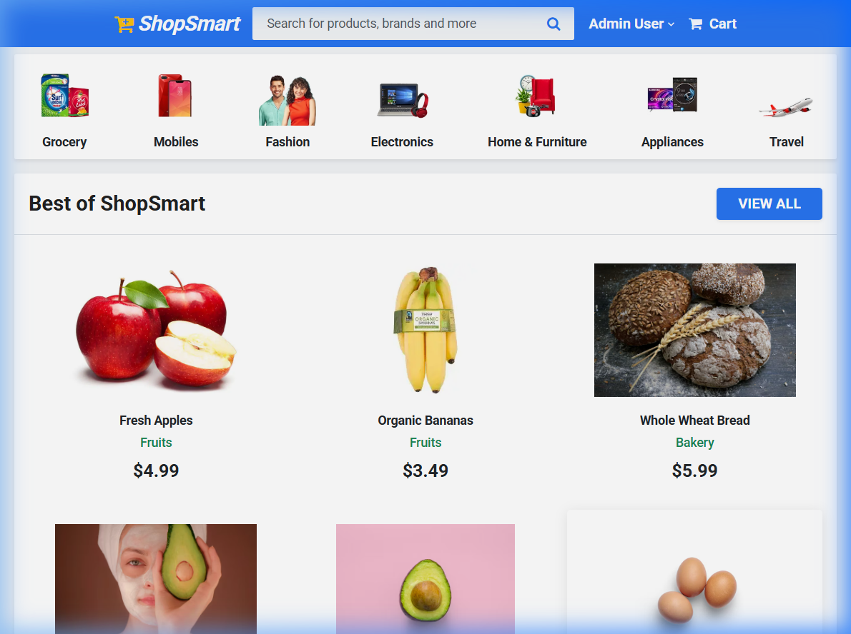
Fig 1: Homepage Layout

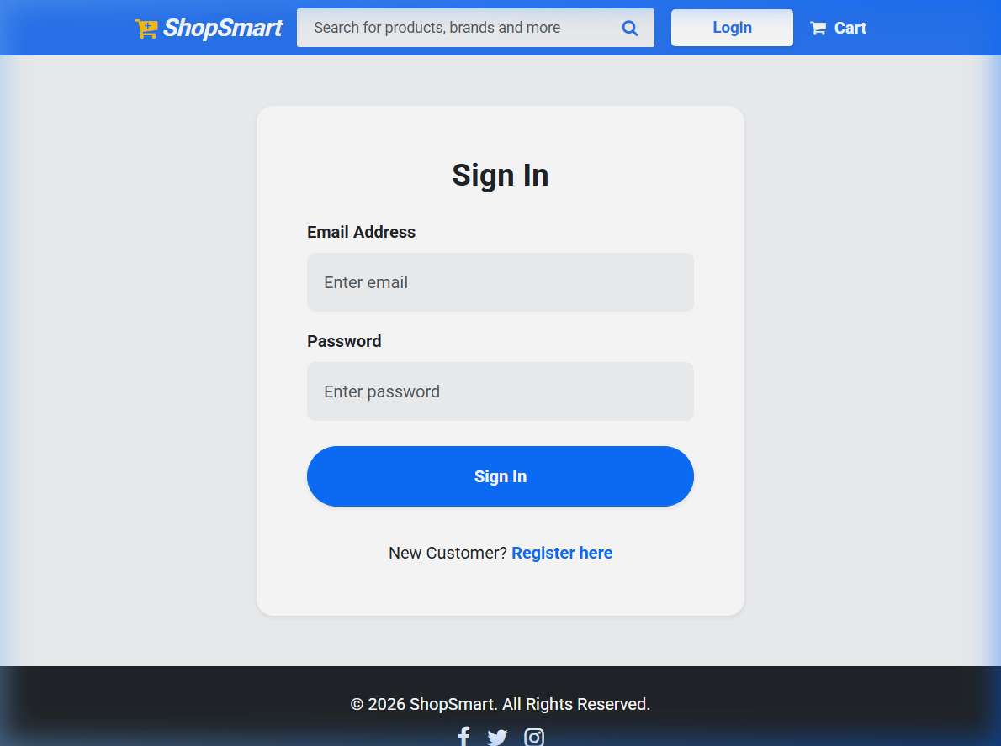
Fig 2: Sign In page

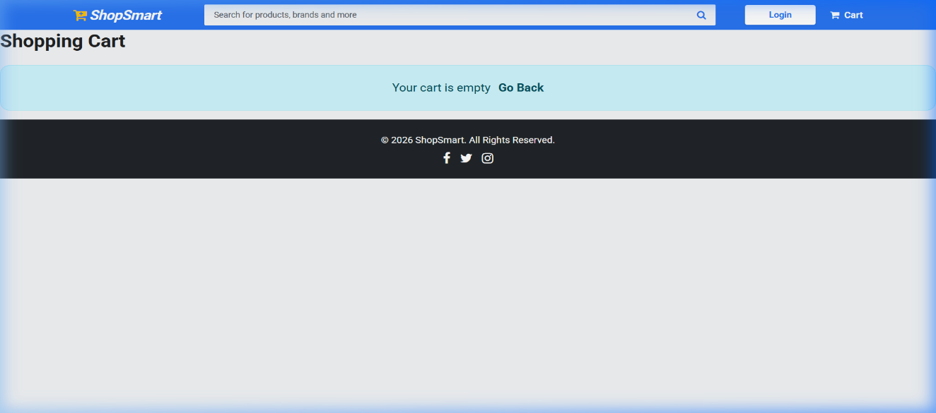
Fig 3: Cart with items page

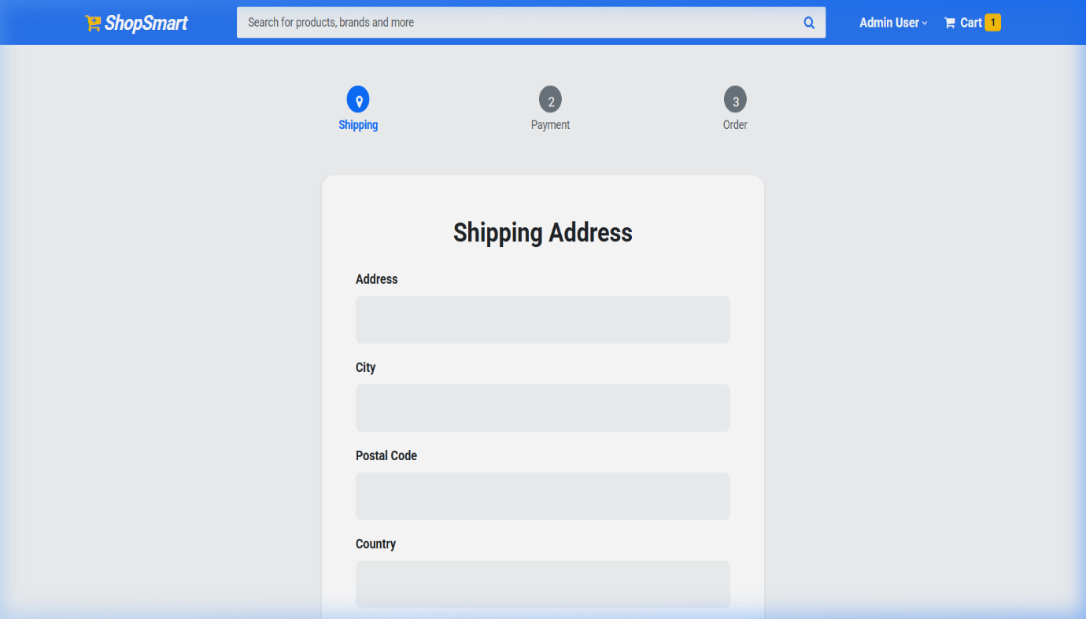
Fig 4: Shipping address filling page

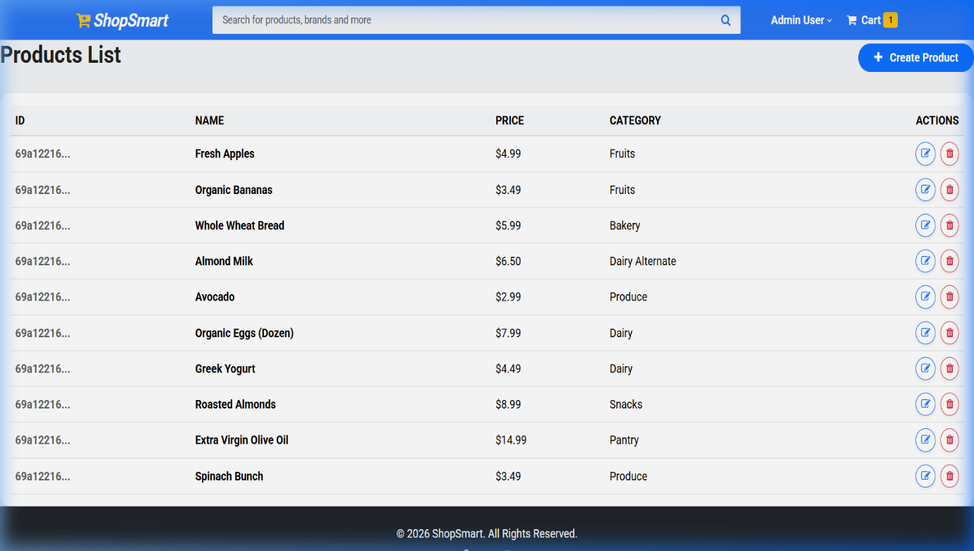
Fig 5: Product Listing and Total price calculation

8. ADVANTAGES & DISADVANTAGES
Advantages
- Simple and lightweight
- Easy to understand architecture
- Real-time updates
- Good foundational learning project
- Responsive design
Disadvantages
- No backend integration
- No database storage
- Cart resets on refresh
- No authentication system
9. CONCLUSION
ShopSmart successfully demonstrates a scalable, secure, and fully operational modern monolithic web application utilizing the MEAN/MERN architectural patterns. The integration of role-based routing, strict security headers, and an elegant UI successfully meets the requirements of a production-ready e-commerce platform.

10. FUTURE SCOPE
Future enhancements include:
- Backend development using Node.js & Express
- Database integration using MongoDB
- User authentication system
- Payment gateway integration
- Admin dashboard
- Cart persistence using Local Storage
- REST API integration

11. APPENDIX
GitHub & Project Demo Link
https://github.com/sai-0309/SmartBridge.git
https://smart-bridge-omega.vercel.app/

